Quad-Creaser Installation Instructions for Horizon BQ Binders
(Models Include: 470, 480 & 500)
Important
Before installation please check the motor that drives the creasing shafts uses the red labelled motor. The original black labelled motor is not strong enough to drive the shafts.
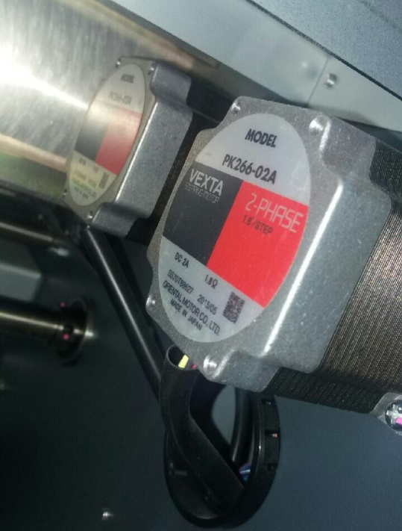
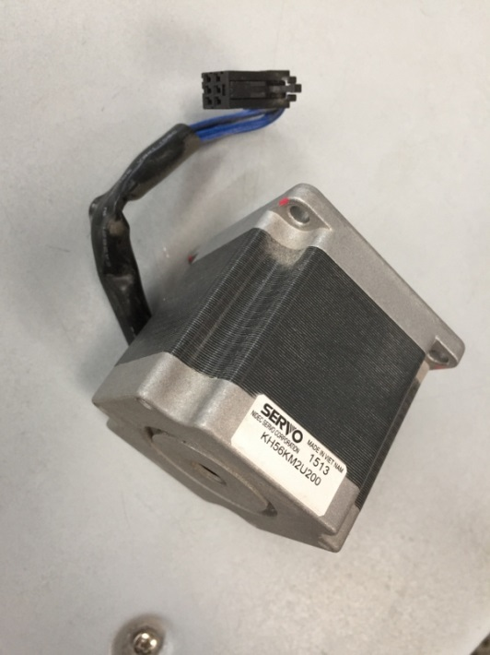
New motor is OK
X Old motor is not strong enough

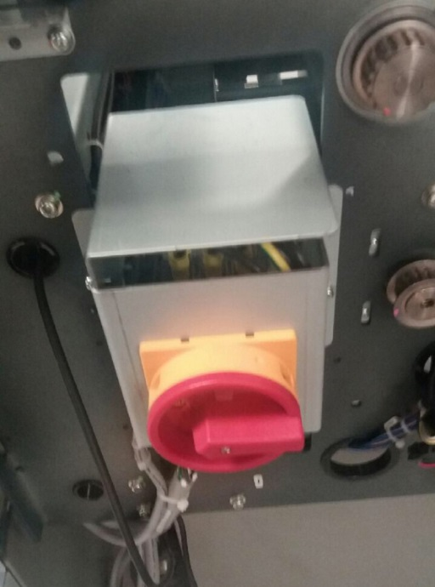

The servo motor is located behind the main switch. Please remove the main switch bracket to gain access to the servo motor

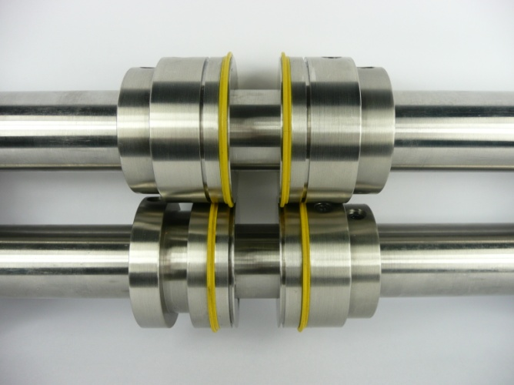
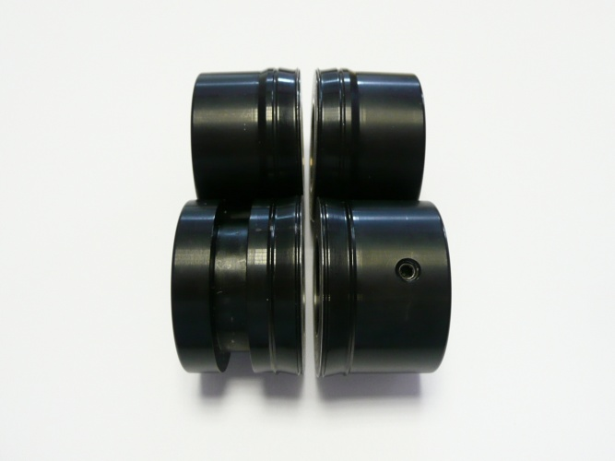

Original Crease System Tech-ni-Fold Crease System
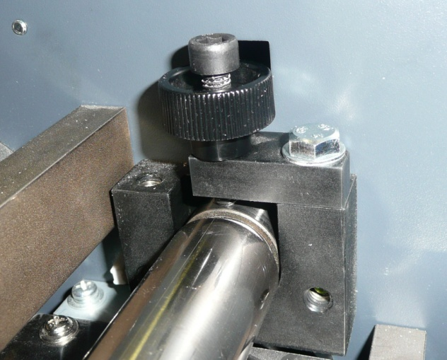
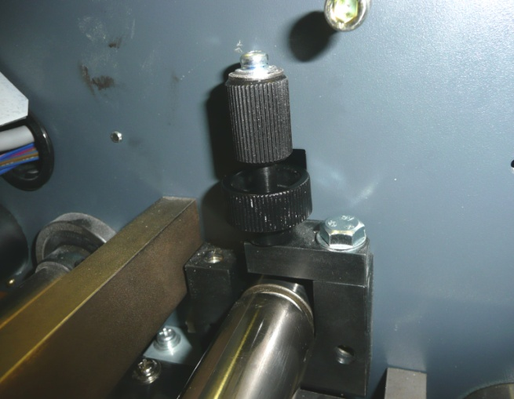

Hexagon cap head screws are included in the pack. Use a hexagon key to adjust the pressure screw.
It is recommended to replace the original top shaft pressure screws as the grip knob is very close to the framework and is difficult to adjust.

Setting the Spine & Hinge Creaser
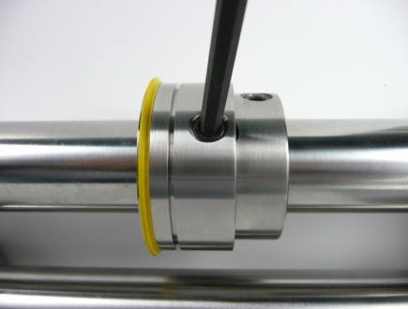
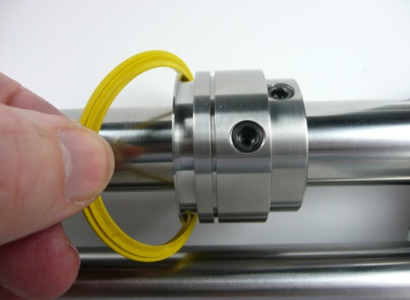
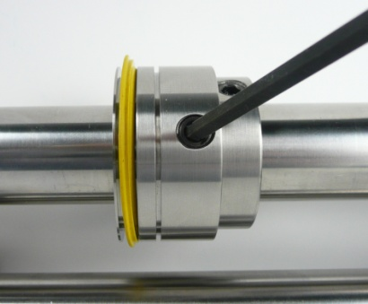

When changing from one stock weight to another you may need to change to another creasing rib. The split design of the rib makes it quick and easy.

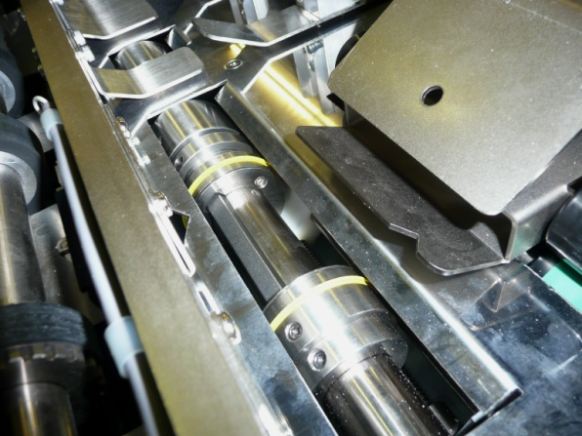
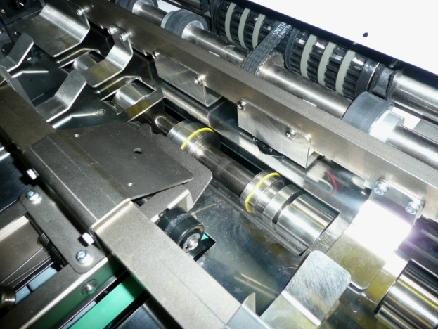

To release and change the crease rib on the bottom shaft driven crease unit, instruct the machine to open the book spine width to 60mm.
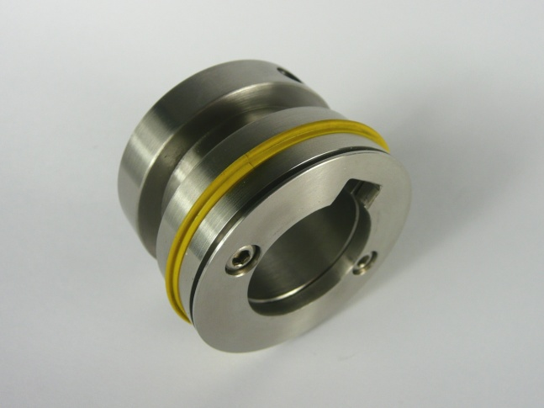
Using the supplied 3mm hexagon key, loosen the 2 crease rib fixing screws on the side of the holder.

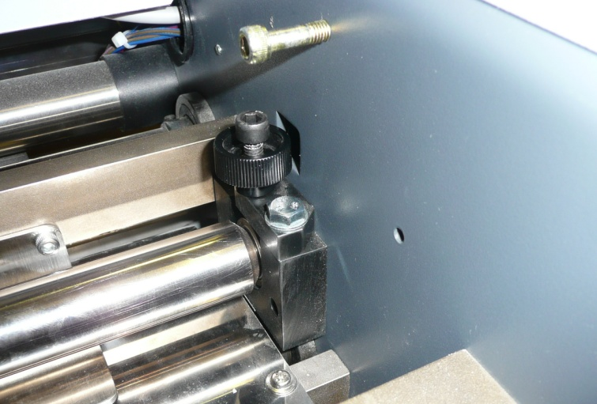
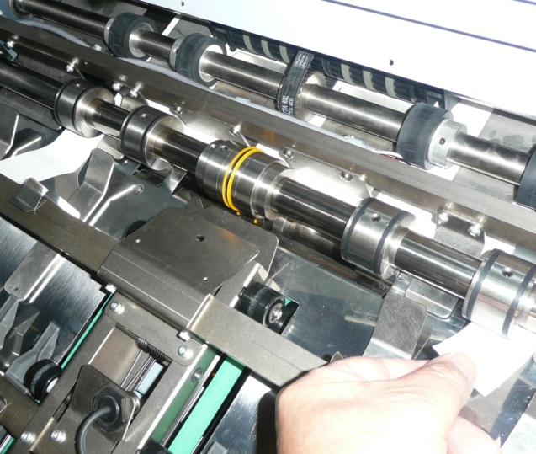
A

Important To set the depth of crease, screw down the shaft pressure screws A.
As a general guide place 2 sheets of 300gsm stock under the support collars on each side of the machine. Place your hand under the top crease shaft and gently lift. At the same time increase the pressure on the adjustable screws (A) until a slight grip is achieved on the 300gsm cover stock. Remove the cover stock strips.
There should be a small amount of movement between the top and bottom shafts. If the shafts are tightened too close together the top creasing shaft will stop rotating when the cover is fed through the machine.

Leave the fixing screws loose until a sheet of cover stock is rotated in-between the creasing units.
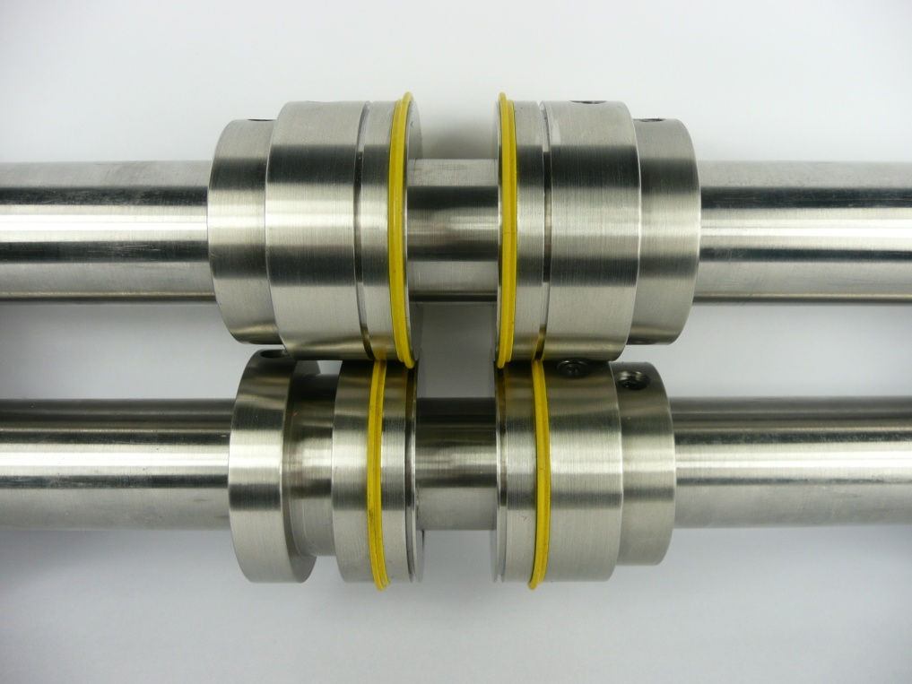

Tighten the shaft fixing screws in the desired position.

Slowly run a sheet of cover stock between the crease units. As the cover stock rotates through the crease units the loose top crease units automatically centralise to the optimum crease position. Tighten down the top-shaft crease unit fixing screws when they come into view.
To achieve the optimum crease position the crease ribs must locate into the centre of the female channels.
Crease Rib Guide
Blue Split Creasing Ribs (M-90):
used to crease medium stock material 100-280gsm
Yellow Split Creasing Ribs (M-89):
used to crease heavy stock material 250-350gsm
Yellow Nylon Creasing Ribs (HO-ST/YE-PC):
used for creasing heavy and laminated stock material
Important
Creasing heavy covers
As the top creasing shaft is not driven by a motor the shaft can stop rotating when a heavy cover from 300gsm upwards passes under the creasing parts. To overcome this problem place the same cover paper you are going to use on the book under the support collars and adjust the pressure setting so that a light grip is achieved. This procedure automatically sets the pressure of crease to the right depth. It will then be necessary to slide away the top shaft support collars so that the top and bottom support collars are not directly adjacent to each other.
By carrying out this simple operation you will now be able to crease up to 450gsm.

